## **UITextField Delegation with Storyboards**

This tutorial will lead you through the creation of a simple app that has a username textfield and a password textfield with the following functionality:

* The password textfield will become active when the Return key is pressed while editing the username textfield
* The keyboard will hide when the Return key is pressed while editing the password textfield
* Text changes in the username textfield will be limited to disallow spaces
* The clear button will allow one-tap clearing of text in the username and password textfields

### **Create a Basic UI**

1. Create a new Xcode Project with the Single View template
2. Add the username UITextField to your storyboard
   * Configure Auto Layout
     + Horizontally center the textfield in the view controller
     + Offset the textfield 100pts vertically from the Top Layout Guide
     + Set the width to 200pts and the height to 30pts
     + 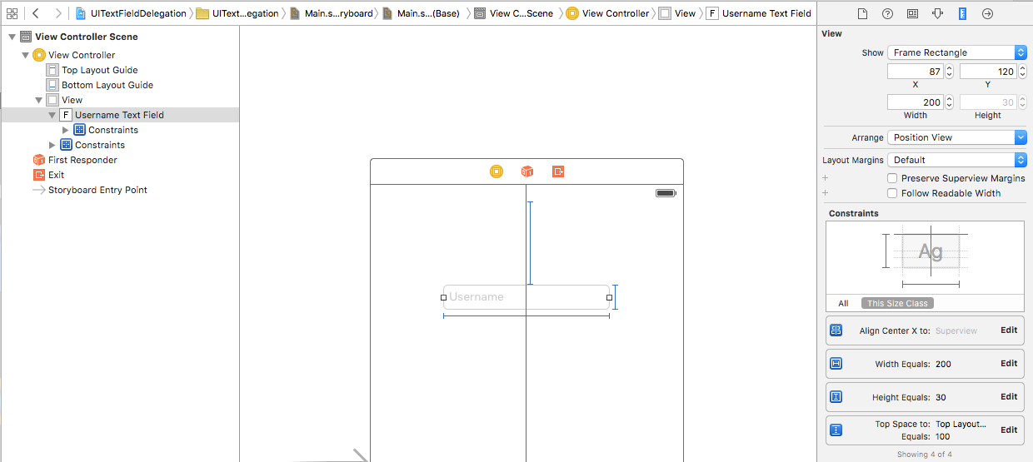
   * Configure Attributes
     + Add the placeholder text 'Username'
     + Enable the clear button while editing
     + Set the Return key's text to 'Next'
     + Disable Auto Correction
     + 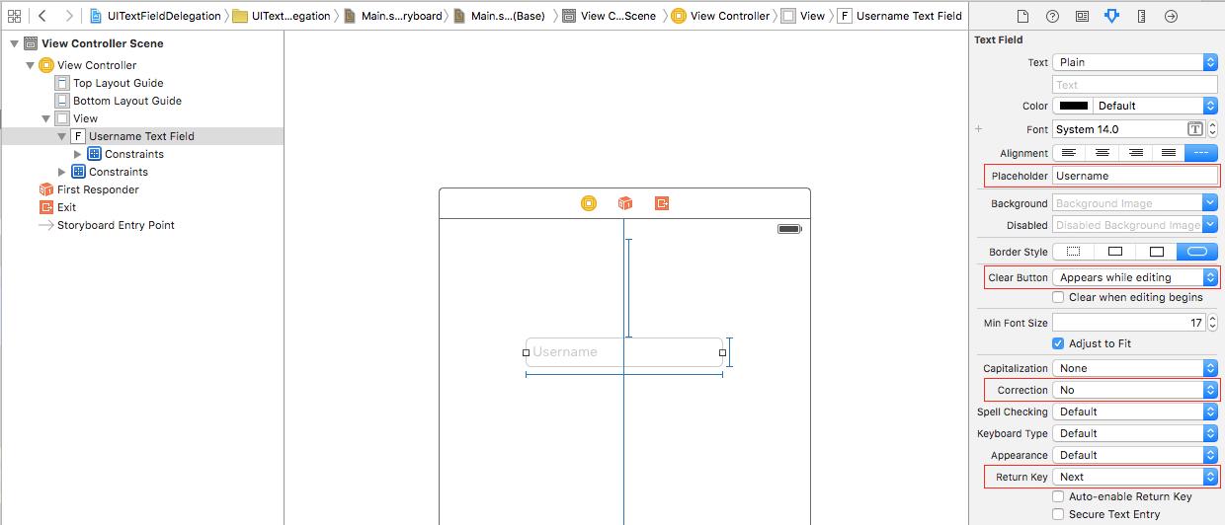
3. Add the password UITextField to your storyboard
   * Configure Auto Layout
     + Horizontally center the textfield in the view controller
     + Offset the password textfield 20pts below from the username textfield
     + Set the width to 200pts and the height to 30pts
     + 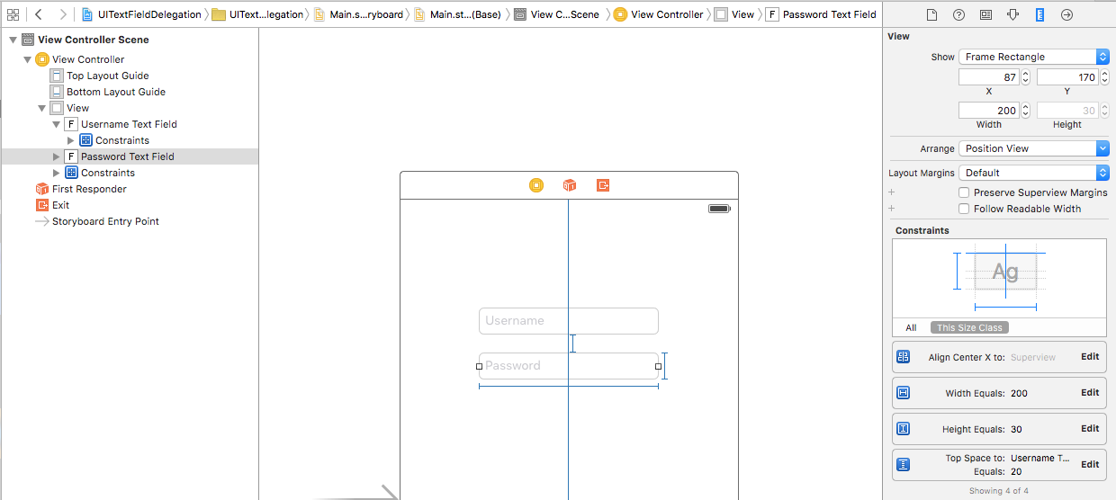
   * Configure Attributes
     + Add the placeholder text 'Password'
     + Enable the clear button while editing
     + Set the Return key's text to 'Done'
     + Enable Secure Text Entry to display bullets while entering text
     + 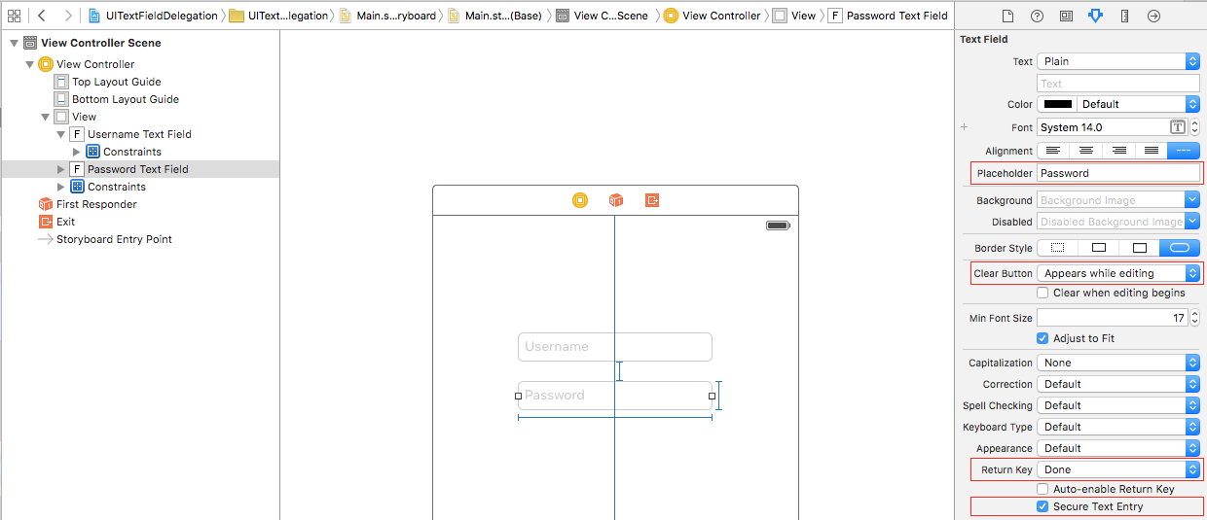

### **Add Outlets and Delegates**

1. Add outlet properties for your textfields
   * Add a weak UITextField outlet for your username textfield called usernameTextField
   * Add a weak UITextField outlet for your password textfield called passwordTextField
   * 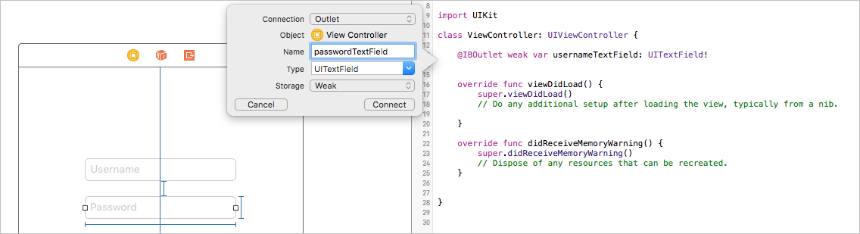
2. Add your ViewController class as the delegate for your textfields
   * Have your ViewController class adopt the UITextFieldDelegate protocol
   * 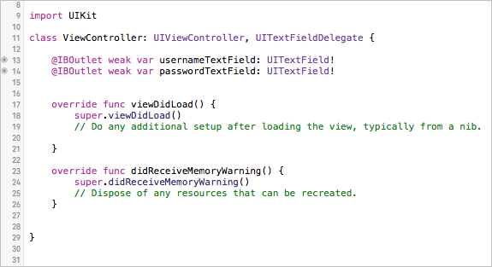
   * Hook up delegates in your storyboard
     + In your storyboard, Control-drag from usernameTextField to your ViewController, and select delegate
     + In your storyboard, Control-drag from passwordTextField to your ViewController, and select delegate
   * This will set your ViewController class as the delegate property for both textfields
   * 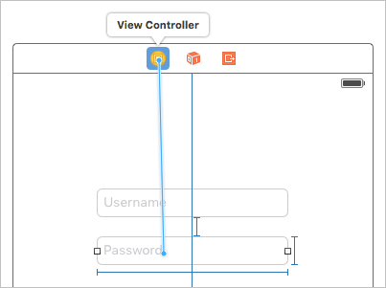
   * 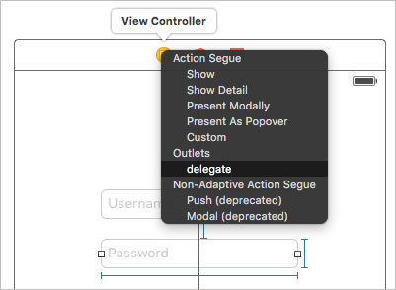

### **Add Delegate Methods**

1. Add and test delegate methods
   * Add all of the methods defined by the UITextFieldDelegate protocol to your ViewController class
   * Add return values to methods that require a return value (the default for all of them should be true)
   * Add a print statement to each method so you can verify they are getting called at the appropriate time
   * 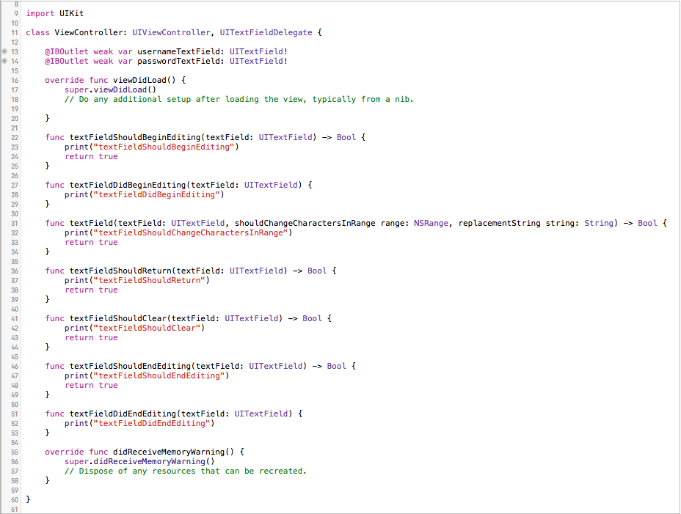
   * Run your app in the simulator and make sure your delegate methods are getting called
2. Configure delegate methods
   * While editing usernameTextfield, we want to make passwordTextfield become active when the Return key is pressed
     + You can force a textfield to gain focus by calling the becomeFirstResponder() method of a textfield
     + You can compare instances of UIView subclasses using the isEqual(_:) method
     + In the textFieldShouldReturn(_:) delegate method, check if the textField being edited is usernameTextField, and if so, then call becomeFirstResponder() on passwordTextField
     + 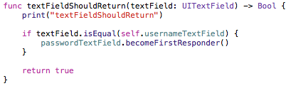
   * While editing passwordTextfield, we want to make the keyboard hide when the Return key is pressed
     + You can force a textfield to lose focus and become inactive by calling the resignFirstResponder()method of a textfield - this will also hide the keyboard in the process
     + In the textFieldShouldReturn(_:) delegate method, add another check to see if the textField being edited is passowrdTextField, and if so, call resignFirstResponder() on passwordTextField, thereby hiding the keyboard
     + 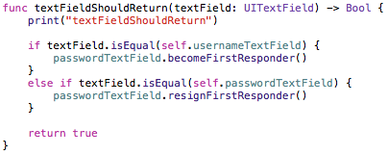
   * We want to prevent spaces from being added to usernameTextField
     + In the textField(_:shouldChangeCharactersInRange:replacementString:) delegate method, check if the active textfield is usernameTextField, and if so, make sure the method only returns true if the replacementString is not a space
     + 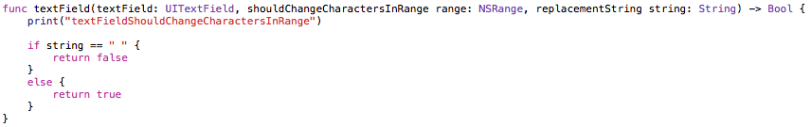
   * We want to enable one-tap clearing of text in the username and password textfields
     + Simply return true in the textFieldShouldClear(_:) delegate method to enable the default handling when the clear button is tapped
     + 

### **Test the App**

1. Run your app in the simulator
   * 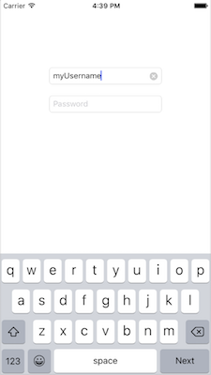
2. Test usernameTextField
   * Add text to usernameTextField and you should see a clear button - tap it and all the text should clear
   * If you try adding a space to usernameTextField, nothing should happen
   * Press the Return key on the keyboard when usernameTextField is selected, and now passwordTextFieldshould be selected
3. Test passwordTextField
   * If you press the Return key while editing passwordTextField, the keyboard should hide